Our project is a WebAPI based project. The reason why we chosen WebAPI project is that APIs can be used in different platform and WebAPI project also support features of MVC architecture.

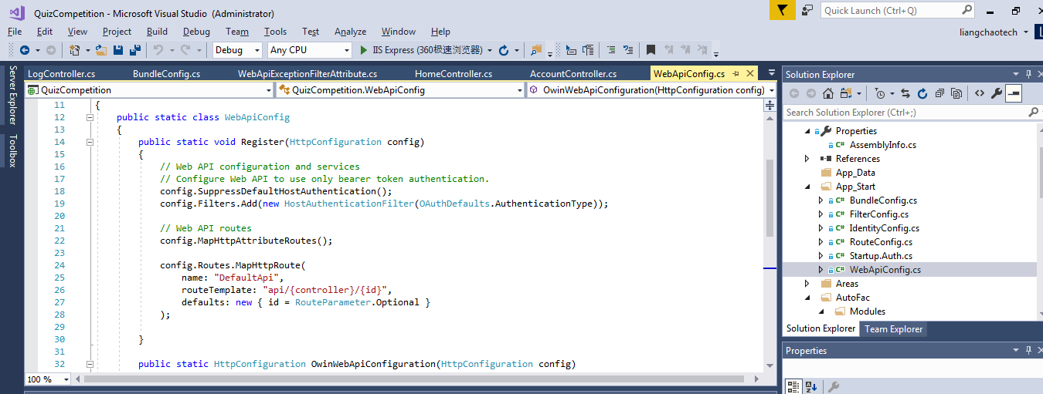

**The Introduction of Application Tools and Frameworks**

1. Visual studio (IDE)

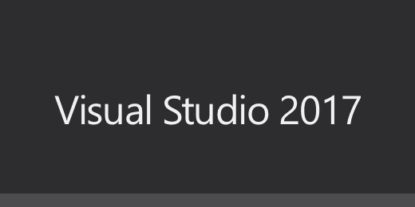

VS is a basic and complete development toolset, which includes most of the tools needed throughout the software life cycle, such as UML tools, code management tools, integrated development environment (IDE), and so on. The written object code applies to all platforms supported by Microsoft, including Microsoft Windows, Windows Mobile, Windows CE,.NET Framework, .NET Compact Framework, Microsoft Silverlight and Windows Phone.

Visual Studio is currently the most popular integrated development environment for Windows platform applications. The latest version is Visual Studio 2017, based on.NET Framework 4.5.2.

1. SQL Server (database)

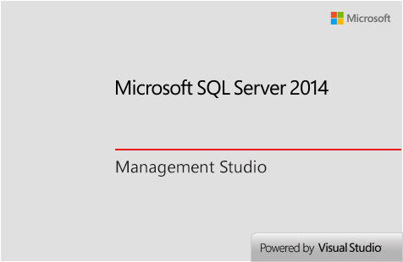

1. Entity Framework (ORM framework)

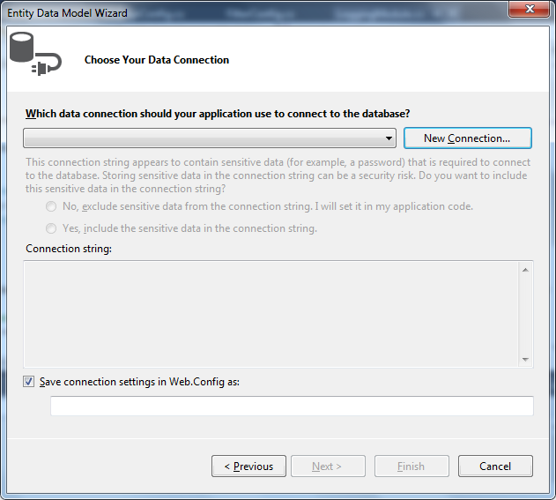

ADO.NET Entity Framework is Microsoft's O/R Mapping solution based on ADO.NET.

1. Source tree and Github (Change management)

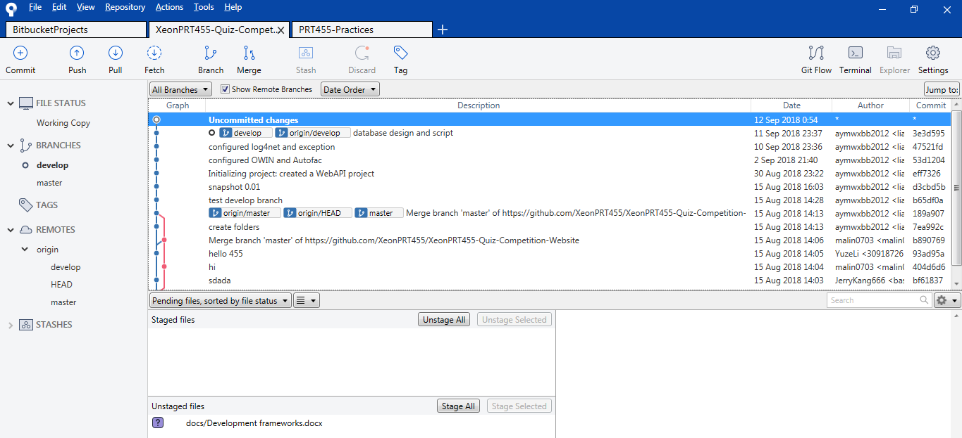

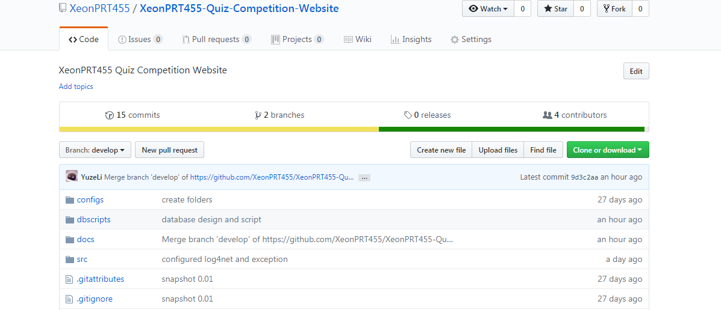

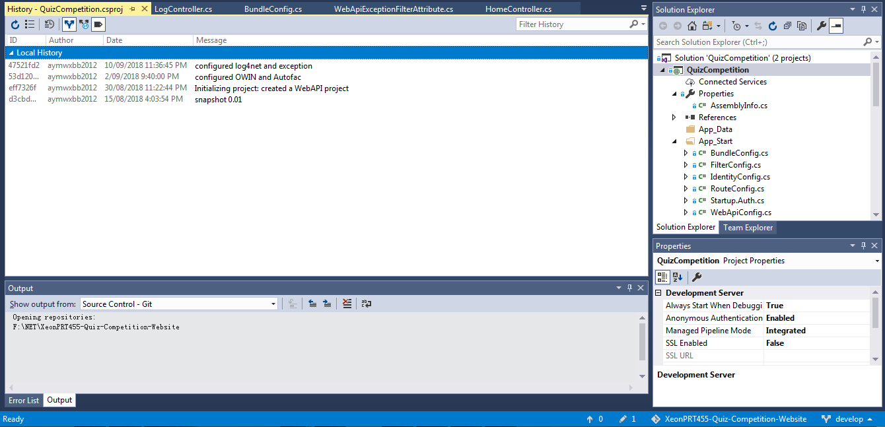

Used in Version control.

The main function is to store source code and revision records into a service

warehouse. Users can connect to this repository through a client program that allows

you to download, view, edit, patch, and submit changes to source code files.

1. OWIN

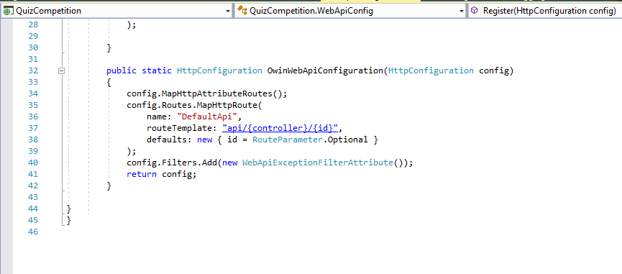

Traditional asp. net websites can only be deployed under iis, but the disadvantage is that web applications and servers (i.e. iis) are coupled, which leads to a simple request that goes through a series of iis-built modules and handlers and other mechanisms (asp. net request pipelines) before it finally reaches the business code. By using OWIN, our project can be more flexible and get rid of some mechanism of IIS.

1. Autofac

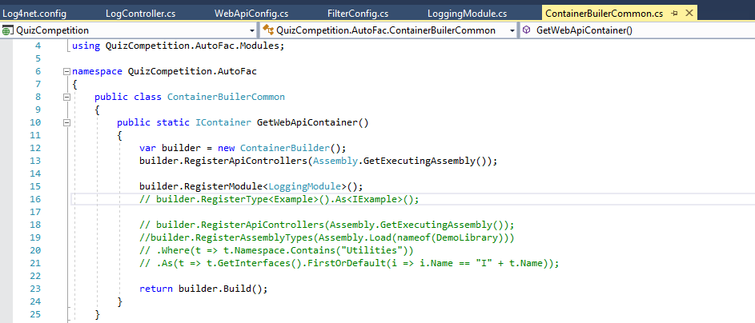

Autofac is an IOC framework. Compared to other IOC frameworks such as Spring.NET, Unity, Castle and so on, it is very lightweight and very high performance.

1. Log4net

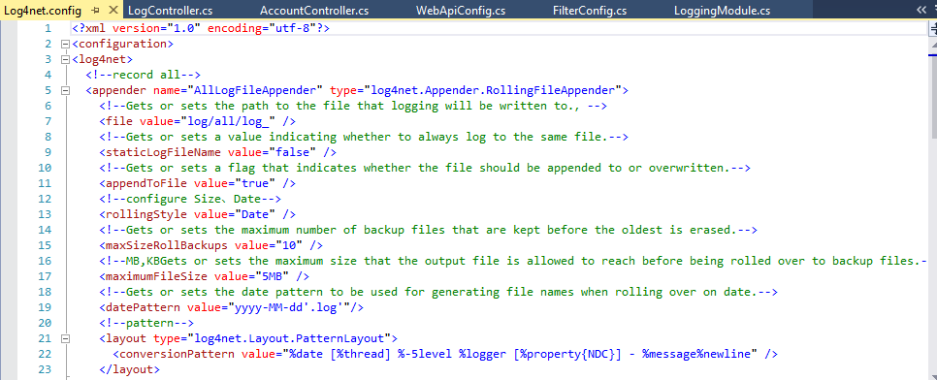

Log4net logging is very powerful. It can divide logs into different levels and output them to different media in different formats.